A Big Thank You - and - Ann Sexton Live At The Wilton

After the disappointment felt by everyone when Marvin Smith was taken ill and had to cancel his concert last November, we felt like calling it a day with regard to live artists at the Wilton’s Soulful Sessions. We continued with the event and, thanks to all who attended, you turned the disappointment into a great success, and helped us financially to recover some of our losses.
We would like to thank all the people who attended, with a special thank you to those who refused their refunds, telling us to put the money towards next year’s event, and because of your support, we have decided to give it another go.
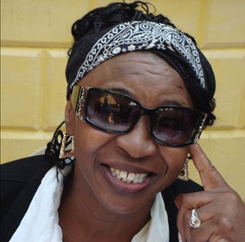
14th November 2015, is our next soul night, featuring a very special performance from a southern soul legend – ANN SEXTON – supported by our incredible full eight piece band, including background vocalists – PUSH.
Let’s give Ann a welcome she will never forget, with a Wilton capacity crowd that, no doubt, will know more about Ann’s recording career than she can probably remember herself.
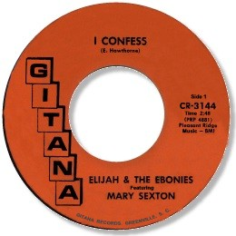
Ann’s sets will include her well known songs from the 70’s, deep and uptempo classics that she recorded initially for David Lee’s Impel label and later for John Richbourg’s (R) Seventy Seven label, something for everyone’s taste. We have asked Ann to perform something extra special, her very first recording that she cut way back in 1967. She was the featured vocalist on a track cut by Elijah and the Ebonies titled “I Confess”, a great ballad issued on the Gitana label, cut in Ann’s hometown of Greenville, South Carolina. On this release she was featured as Mary Sexton and must have been in her late teens when this recording was released. We are so pleased and privileged that Ann has agreed to perform this song onstage at the Wilton for the very first time in Europe since she recorded the song all those years ago. To make sure we’ve covered all the bases, Ann will perform her latest 2010 release “Rising Up”, a fantastic uptempo soulful house track.
Tickets are now on sale at £20.00 or online at £21.50 at www.wheatsheaf.com/allnighter – watch the Soul Source events guide and the Wilton’s pages on Facebook for updates.
Looking forward to November.
Dave and Val.

Wilton's Soulful Sessions Saturday 14th November 2015

A Soulful Night Featuring A Very Special Performance From A Southern Soul Legend
***** ANN SEXTON *****

Supported by an incredible full eight piece band - PUSH - including background vocalists.

We are so proud to have Ann Sexton performing at the Wilton. Ann depicts the roots of black women by illustrating, through song, joy - pain - love - frustration, and self-assurance. With a force of power she sings some soulful songs which include:

" I Had A Fight With love" ;"Who's Gonna Love You" ;"Color My World Blue" ;"Be Serious"
"You've Been Gone Too Long" ;"I Still Love You" ;"You Got To Use What You Got" and many more ....

Ann will win your hearts in the way she soulfully sings the slower tunes, whilst at the same time have you jumping all over when she ups the tempo.

Once again, another not to be missed soulful night at the Wilton.
Plus the very best of 60's - 70's - Crossover from our DJ's:
ARTHUR FENN - MIKE CHARLTON
plus Residents BOXY & MOUSE.

9.00PM - 3.00AM ADMISSION: Advance Tickets £20.00 - £23.00 otd if not sold out. Tickets available at www.wheatsheaf.com/allnighter by PayPal at £21.50 which includes PayPal and postal charges.

***** Tickets are now available *****

from the website or by contacting: BOXY - 01924 894555, MOUSE - 07717 338009
Latest Update - (7th July 2015)
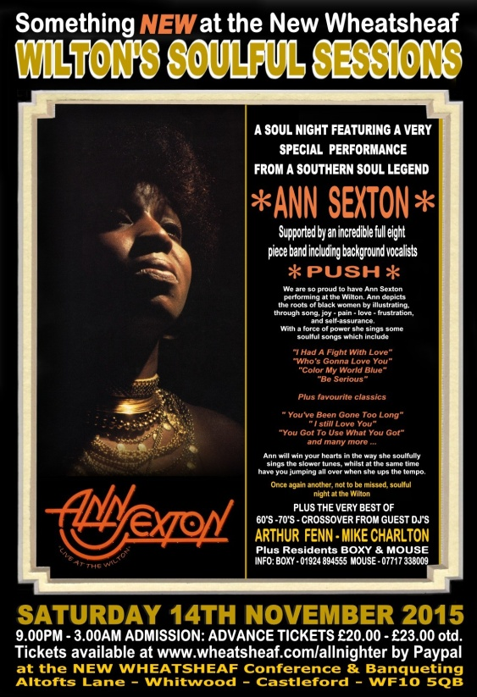
It’s been a long time since we sent this original email round to all you guys, so we thought it was time to let you know what’s been going on over the past few months. Well, Ann signed the contract some months ago, so tickets went on sale. The response for tickets has been great - we didn’t start selling tickets for last year’s concert until July, but this year we have sold around 100 tickets already, which is fantastic. We have had sales from the length and breadth of the UK.
Ann has recorded some great songs, so the task to decide the song list for the concert has been a tough one, but we have just about completed a list that will included something for everybody’s taste. Ann’s concert will be split into two 30 minute sets, just as we did with Debbie Taylor.
Ann’s set will cover the full spectrum of her career starting in 1967 with “I Confess”, touching on Deep/Midtempo/Uptempo/Funk from the 70’s, and finally Soulful House from 2010. Ann has agreed the song list and the songs and the keys have been passed on to the band.
Ann’s flights and hotels are now booked, the band’s hotel is also booked. The sound guys and sound equipment for the concert is also finalised. Work permits for Ann will be issued a few weeks before the concert. Well, that sounds like it’s sorted, just about, but just like any project, fine adjustments will be needed along the way to November 14th.
All we need now is for all our Wilton Allnighter guys to get their act together and get their tickets before it’s too late. This email is addressed to most of people who have attended the Wilton Allnighter at some time in its 20 year history, and other people that have attended our recent soul nights and live artist events.
This concert is an event not to be missed and is looking like a sell out night, so don’t leave it to the last minute and be disappointed. Get a ticket now and just sit back and wait for the 14th November. Most people who have already got tickets have also booked in the local hotels, deals are now available for November booking at around £35 per room; these hotels are not massive and soon will be sold out.
Dave & Val

