** Mal.C NORTHERN SOUL SALES **

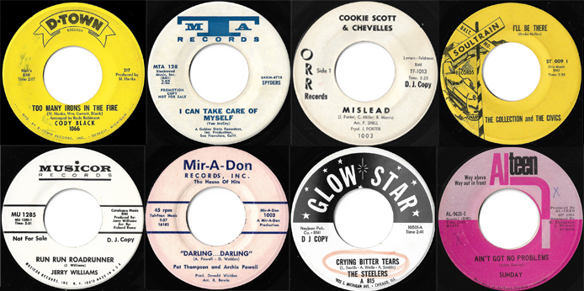

Malcolm Collins
25 Crescent Road
Risca
Caerphilly
S-Wales
Tel: 07831 095717
Email: malcolmc300@gmail.com

Payment
By PayPal either as Friends & Family or please pay the additional Pay Pal Fees (4%), meaning I must receive the full sale amount, not less any PayPal fees. You can also pay me direct into my Bank Account, please contact me and I will send over the account number / sort code.

Postage
1st Class Signed for (Insured up to £50) within the UK - £3.00
Special Delivery (Insured up to £500) Within the UK - £7.50
Special Delivery (Insured up to £1000) Within the UK - £8.50
if you are located Overseas, get in touch and I’ll quote you separately

Grading
Don’t Use Mint much, as there are not many out there that actually are, but, EX++ is next to mint as it can be for a sixties record in my book, and decreases EX+,VG++, VG+ VG I’m straight on grades, and if I’ve missed anything happy to refund

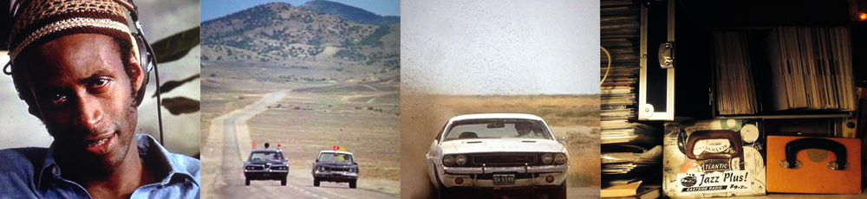
For all you Super Soul Challenger’s, get through em Baby, Get through em!

*** USA Released Northern Soul ***

Stormy – I Won’t Stop to Cry / The Devastator / Twinight EX+ (dh)
I bought this for ‘Wont Stop to Cry’ but the flip seems to also be very in demand.
Vinyl has some superficial marks, but nothing affecting the play what so ever, it’s a good copy.

£600

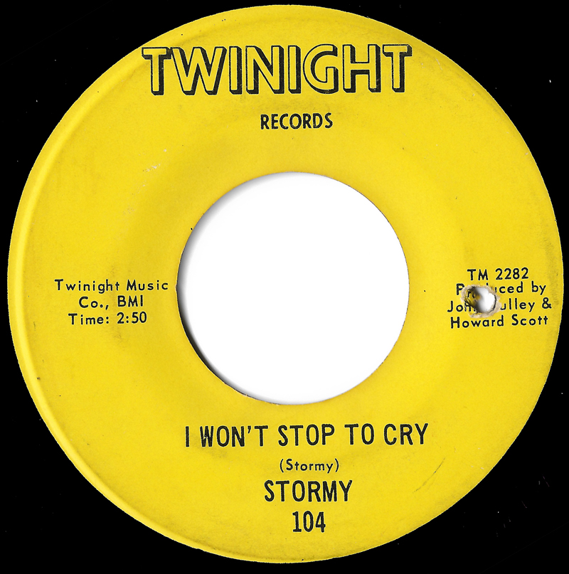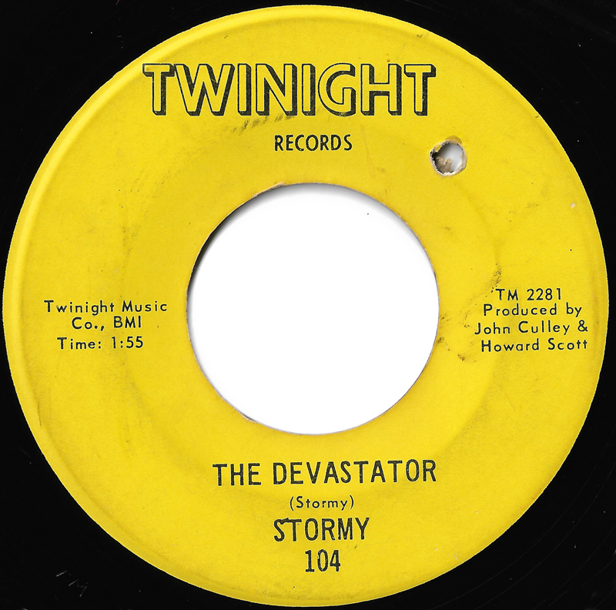

The Greater Experience – Don’t Forget to Remember / Colony 13 M- £650
Steaming mint original, really beautiful copy.

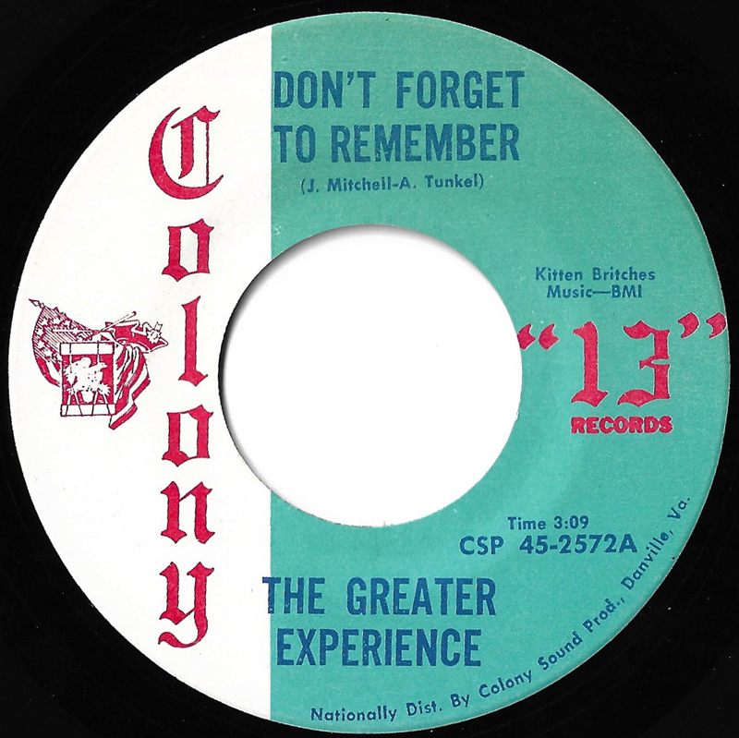
2/The Collection & the Civics – I’ll be There / Soul Train EX++ £250

3/ The Exits – I Don’t Want to Discuss It / Gemini WD EX++ £150
Same track both sides, bit of label staining but does not detract at all.

4/Jerry Williams – Run Run Roadrunner – Musicor WD M- £50
Spanking copy, this came from John Anderson when he lived in Scotland, he nearly didn’t want to sell it me, said he liked it so much…

5/ Cookie Scott & Chevelles – Mislead / Mislead Inst / ORR WD EX++ £175
White Demo with the Inst on the flip, Crossover of the highest order, as they say…

6/ The Penetrations – Champagne (Shing-A-Ling)/Sweet Sweet Baby / Highland VG
(label wear/swol) £300
Second Label after Teri-de, but still rare 45, looks beat up, see below scans, but as the guy who sold it me said, plays fine with a bit of crackle, Champagne side is better, & that’s a better track anyhow. He said he was happy with it all the years he had owned it, and so have I been, allot cheaper than a mint one that for sure.

7/ The Steelers – Crying Bitter Tears / Glow Star DJ Copy EX++ £50
Came out on Crash records as well, great Chicago group 45, Don’t know which one was first, but this is a very cool looking demo with the title highlighted as radio DJ’s do..

8/ Pat Thompson & Archie Powell –“Darling… Darling” / Miradon (Pink) EX++ £85

9/ Lonnie Lester & Chuck Danzy – Ain’t That a Shame / Nu-Tone WD EX++ £140
I never liked their other track ‘You Cant Go’ no finesse what so ever, this however is brilliant, its rocks, its got great guitar work, fookin cool record.

10/ Sunday – Aint Got no More Problems / Alteen EX++ (sxol) £150
Has been discussed allot recently, perennial favourite 45, this is one of three or four label designs I’m told, all sound the same to me…

11/ The Venturas – Baby Be Mine / When we First Met / Daniels EX++ £200
Their other track from the ‘Green Light’ release, both sides are very very good ☺

12/ Sissie Houston – Don’t Come Running to Me / Kapp DW EX+£75

13/ Lee Harvey – My Assurance / J Gems EX+ (s-hairline nap) £120
The rarer way to get this track, nice yellow issue.

14/ The Four Sonics – Easier said than Done / Sport WD EX++ (wol) £120
Says writing on label, but its actually a printed ‘29’ so I guess that may have been a chart position or something? Doesn’t detract, looks great.

15/ Jimmy Witherspoon – Love me Right / Prestige WD EX++ £75
Also on his Prestige LP, so I can sell the 45. More of a 100 club sound this one, also came out on UK Stateside.

16/ The Paramounts – Under Your Spell / MAGNUM EX++£125
Steaming mint west coast Vinyl copy.

17/ Fabulous Four – If I Knew / Saintimo EX++£45

18/ Bobby Sansom – “Don’t Leave” / Sublime (swol) otherwise EX++ £100

19/ Bull & the Matadors – If You Decide / Toddlin Town WD EX+£15
Cool record! First head this of Buey, it’s a demo with the Promo bit marked out as so may were…

20/ The Masterkeys – If You Haven’t Got love / Sport (Yellow Issue) EX+£45
Cheap Detroiters!

21/ The Soul Three – Temptation Walk / Omen VG+ (label wear) £20
This 45 the styrene looks awful, the label has wear but it plays fine, loud track anyhow, and it’s a cool track.. Priced accordingly

22/ Scotty Williams – Fear / Mona-Lee WD VG++£85
This 45 the label is a bit tired, vinyl has marks but nothing that makes it bad at all, it’s a solid copy I would say.

23/ The Majors – Lost in the City / BIG Three VG+£60
The label on this 45 is very dark, allot are on this track, has surface marks, but plays fine, actually adds the general “Street Corner” feel. Great Chicago slowie.

24/ Allison & Calvin Turner, Fabulous Sound Masters – Yeah, Memories / Lamp VG+£45
Don’t be put off by the title, this is a really great group track, very much in the mold of the Majors above.
25/ Darlettes – Lost / Mira WD EX++ £75
West Coast Girl Group Greatness, lovely WD, bought this from Rick (RIP) on Tim Brown’s list, he under-priced it and we had quite a negotiation that day as Rick had to come back to me after id made payment and ask for more dosh… and he got it… he was a lovely bloke…
26/ The Ballads – I Can’t See Your Love (For the Tears in my Eyes) VJ WD / EX++ £180

27/ Romance Watson – Where Does That Leave Me / Coral YD EX++£180
100 club at about 3 in the morning! That’s when ‘Romance’ does his damage! And we love him for it!

28/ Shades of Jade – Is It Wrong / CENCO VG+ (lbl stain) £250
Has stain on the label, see scans below, and some marks on the vinyl, but plays fine, kickin track!

30/ Linda Grinder – Goodbye Cruel Love / Motown WD VG+£200
Not the miss-pressed rarity, but still a fabulous early Motown track. Label and vinyl are a VG level, but again this plays fine with a small amount of sound, in fact I can’t hear any hiss but them I’m half deaf!

31/ Jimmie Raye – You Must be Losing Your Mind/For the Sake of Love / Garrison WD EX++£150

32/ Eddie Hill – Nothing Sweeter / MS Records EX+ £100
This has a very slight hairline crack from the label outwards about 2cm, be honest its really hard to spot and does not effect the play what so ever. If you bend this 45, it won’t show, but its there… Otherwise this would be EX++ really nice label and play. Happy to send pictures if you want to see them.

33/ ST. George & Tana – Without Your Heart / Kapp WD EX+£25

34/ Little Willie Pollard – No Money / ARC EX++£20
I think this is the second label on this track, sill brilliant R&B slowie

35/ The Fiats – Speak Words Of Love / Universal (Blue Issue) EX+£75
Really nice Blue / Silver Issue, much nicer than the Demos.

36/ Milt Greyson – Your Old Standby / Derby EX+ (wol) £75

37/ Garnet Sykes – Longer Than Forever / Musette (Orange) EX++ £50
Very collectable main stay of the label Garnet Sykes.

38/ Lenni Groves – Sweet Sixteen / Fool for a day / Musette (Yellow) EX++£40
Not many of these about with the yellow label, I had most of the known Musette label releases years back, kept this because it was said to be Green label at the time, I bust that one wide open eh! Looks mad in yellow.

39/ Della Reese – A Clock That’s Got No Hands / RCA Blk Issue, EX++£60
this became big sound in 98,99, great track, and Hugo & Luigi Produced ;-)) been reissued recently as well.

40/ Pat Lewis – Warning / I’ll Wait / Solid Hit EX++ (xol) £75
Detroit Classic! Very Nice copy.

41/ Lee Stone – Gonna Put You Down / SHAW WD EX+£150

42/ Colette Kelly – City of Fools / Vault WD (Vinyl one) (sxol) £125 EX++
Vinyl Demo, the one to get!

43/ Liz Lands – Midnight Johnny / Gordy EX++ (dh) £70
This is the rarer Gordy Label design, which I’m told was a seventies re release, same cat number and mastering, but with a label design for the time, looks well cool, check out the scans.

44/ The Four Voices – Your love is Getting Stronger / Voice (2nd ‘Gold’ Issue) EX++£60

45/ Jackey Beavers – Bring me all Your Heartaches / Grand Land EX++£175
Really nice Green Issue, Ive never seen a demo on this one.

46/ Jimmy Stokes – Keep on Goin’ / SIANA Promo £150 M- a tad off Mint, Lovely copy
Moody Dancer, I’ve had a few copies of this over the years, a 45 that seems to always be championed by
Pat Brady, I think I’m right in saying he broke it at Stafford.

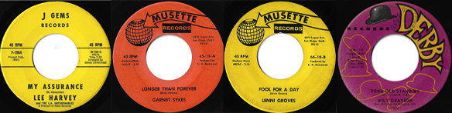

47/ Troy Dodds – Count of Love / I’m so in Love with You / Daytona WD EX+ (xol) £85
Rare on WD this track, ‘So In Love’ is a raw different version of ‘Rise Up and Walk’ that came out on Penthouse, you can hear the recording studio walls in this one, it’s a truly raw and fabulous record…

48/ Cody Black – Too Many Irons in the Fire / D-Town EX+ (wol) - £90
Some rub marks on the play side label, check out the scans, vinyl is clean, Sheldon stamped.

49/ Lee Jones & Sounds of Soul – On the Other Side/This Heart is Haunted / Amy EX+(dh)-£65
Deep soul double sider of epic proportion! My favourite is OTOS, from the pens of Dan Penn & Spooner Oldham.

50/ Brooks Odell – Standing Tall / Columbia EX++£35

51/ The Dynasonics – You Got it / Soul Bug / Dynamics EX++ £25
Two cool Detroit Instrumentals. Nice glossy label, clean vinyl.

52/ Deena Johnson – The Breaking Point / Wild Deuce WD EX++ £95
Supreme Beat Ballad, nice on White Demo.

53/ The Sensations – Baby / Junior WD EX++ £140
I was so into this 45 for years, it really is a great catchy song.

54/ Sharon Soul – How Can I Get to You / Wild Deuce (Blue Issue) EX+£35

55/ Bobby Byrd – Lost in the Mood of Changes / Smash EX++ (dh) £25

56/ Mike & the Censations – Don’t Sell Your Soul / Baby What’re Gonna Do / Highland WD EX+ (w&xol) £15
Nice Glossy Label, vinyl is clean, Looks to have been owned by ‘Eddy’ !

57/ Jimmy Richards – (I Wont Be Responsible) / A&M WD EX++ £45
His best of I think 3 tracks on A&M, this is a killer slowie!

58/ Melvin Carter – Teacher of Love / Peacock Demo Ex++ (Date Stmpd) £35
Had this loads of times, but this copy is a date Stamped Demo, makes it allot nicer ☺ Nov 27th 1965…

59/ Freddie Scott – (You) Got What I Need / Shout WD EX++£75
This is Gamble Huff written and produced; I’ve always thought it sounded like a Don Davis Production. Great record with a Detroit feel. Had a bit of interest in the last 12 months I think.

60/ The Valentines – Gotta Get Yourself Together / SS7 WD EX++£20
Their other track on SS7, different record from ‘Breakaway’, really nice mid tempo.

61/ The Contessas – I Keep on Keepin On / E Records (Red Demo) EX++£20

62/ The Mandells – Don’t Turn Your Back on Me / Hour Glass EX++£10

63/ Dori Grayson – Try Love / Murco VG++ £20

64/ Leon Haywood – You Don’t want to see me Cry / Decca (Pink Demo) EX++ £25
Nice Pink Decca Demo, they just look and feel good Don’t they.

65/ Exsaveyons – I Don’t Love You No More / Smoke M- £150
Spanking Styrene copy looks and plays perfectly.

67/ Pat Johnson & the Moonlighters – Give me a Helping Hand / Cap Town EX+ £250
I was after this 45 for an age, It’s not very well known but is a very powerful Northern dancer, very cool,
kinda Cult record!

68/ Jesse James – Falling Star / LAWN WD EX++ £250 ONO
Very interesting rarity, On all Lawn Discographies Lawn L-248 is Dick & the Deamonds, however there area few Demo copies of this release under the name 'Jesse James'. Andy Rix has confirmed to me this is the same Philly based Jesse James who wrote ‘The Horse’ and sang ‘Love Is All Right’, the Virtue acetate big in 2000’s, A seriously Rare 45…!

69/ SOLD

70/ Johnny Gilliam – Baby Take me Back / Modern WD EX+ £120

71/ Phyllis Brown – Oh Baby / Why / Rainbow Records EX++ £200
Yellow label release. Both sides of this are simply awesome, if you haven’t heard “Why” I’ll send you a MP3,awesome sixties song…

72/ Lee Williams & the Cymbals – Lost Love / Carnival WD EX+ £125
Drums to die for, if a 45 ever went at it! Then stepped up a gear mid way through, this is it! Northern Soul
at its best!

73/ Claude “Baby” Huey – Drifting / MIOB EX++ £175

74/ The Fantastics – Have a Little Faith / Me and You / SS7 EX++ £250
Two sweet group dance tracks, nothing in them, both as good as each other, and both brilliant.

75/ George Blackwell – Mr Loser / Smoke EX++ (wol) £60

76/ The Danderleers – All the Way / Midas EX+ £120
Labels on Midas 45’s are always weird, the paper looks strange to my eyes, and anyhow this looks a tad
discolored but isn’t… It’s a sound copy!

77/ Jimmy Jones – Walkin’ / Roulette EX++ (dh) £35
Very underrated track, might have been on his LP, Hugo & Luigi Produced and Orch conducted by Bert Keys, so it was always going to be a great track.

78/ The Festivals – Hey Girl / Checkin Out / Blue Rock EX++ £150
Small tear on Checkin Out does not detract at all. If Makings of a Lover is going for over 50 quid this
should be worth twice what I’m asking…

79/ Jerry Jackson – It’s Rough Out There / Parkway WD EX++ £300
Nice West Coast styrene demo, titchy bit of noise at the start, but not over the music if that makes sense.
Nice copy.

80/ Danny Moore – Somebody New / Alright EX++ £80
Might be loads around, but you still gotta have it! Lol

81/ The Turks – The Bad Brought the Good / DJO EX+ (Slight Warp dnap) £200
Their rarer 45 on the DJO Label, Great mid-Tempo group 45…

82/ Mike Hanks & Del-Fi’s – The Hawk / When Love Comes to Pity / Mah’s EX++ £120
First Label before Sparton, also a Mike Hanks Label. This is a collectable Detroit Instrumental 45, which
comes up, less than the Sparton release, and always-in bad condition, this is a nice one and is Sheldon
Stamped.

83/ The Shadows – My Love is Gone / USA EX++ £150
Richard Searling’s George Towns cover up from the late Wigan casino period, originally on Golden Sound
Records, the USA Records copies are my favorite though, they just look dam good!

84/ Yvonne Daniels – I Got to Get Closer to You / Red Light Records EX+ £50
Why this is not a three figure track is anybody’s guess, I could list a dozen common records, not as good
that go for silly money, this is a very good rare soul side, period!

85/ The Thieves – Why Did You Do it To Me / The One / Broadway WD (dh on Runout
nap) £150
Two great sides here, happy to send a scan of the Drill hole.

86/ Pic & Bill – Talk About Love / Charay EX++ £200

87/ The Black Eyed Peas – Smallest Man in Town / Ultra City EX++ £180

88/ The Three Jades – Show me the Way / Maurci EX++ £45
I think this is a very neglected track on this label, and it’s the easiest to get, it’s a sold sixties soul side, in
the Northern style…

89/ Johnny Nash - Strange Feeling / PYE Advance Press Acetate (19 Feb 65) EX+ £40
Nice UK Pye acetate test press

90/ Claude Huey – Why Would You Blow It / Galaxy EX++ £200
Small chip on outside edge, not affecting play at all, otherwise a very Mint 45.

91/ Sunlover’s – You’ll Never Make the Grade / Mutt-Jeff EX++ (1st Orange label) £250
Lovely copy of a brilliant Northern Classic, 1st label release before the yellow label releases.

92/ The Sunlovers – My Poor Heart / Breakthrough M- £150

93/ Charles Diamond & Inspirations – No One Can take Your Place / Inst / Breakthrough
(The 7ts release) EX++ £185

94/ Clay Hunt – Since I’ve Lost You / Kapp WD EX++ £65

95/ Priscilla Page – I’m Pretending / Topper EX++ £150
1st more common Mix, but a better one IMO, knocks spots of the rarer release, Rarity does always mean
quality!

96/ Valarie & Nick – Don’t You Feel Sorry / Somebody’s Lying on Love / Glover WD (Xol) EX++ £75
Two brilliant sides from Val & Nick, two X’s on the ‘SLOY’ side as its an old radio demo.

97/ Gwen Davis – My Man Don’t Think I Know / I Cant Be your Part Time Lover / SS7
EX++ £175

98/ Mary Moultrie – They’re Trying to Tear Us Apart / KING (Blue Issue) EX++ £135
Outstanding track, got a Caribbean type rhythm to it, certainly stands out.

99/ H.J Jackson – Please Forgive Me / Cross-Tone EX++ (ssol) £75
Sure you know this is actually June Jackson of Musette fame. Cool record.

100/ Moses Smith - The Girl Across the Street / Hey love (I Wanna thank you) EX++
£200


