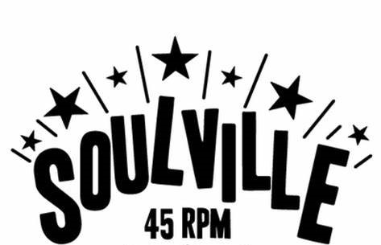
Roose Cons Club
Leece Lane, Barrow-in-Furness LA13 0EB
Saturday 14th May
7.30pm till Late!
Across the board Soul from great local DJs:
Dave Harrison
Colin Wall
Roger Moffatt
& back in Barrow for the
first time in 7 years – Phil Threlfall
Door tax £5 all in aid of Ukrainian Refugees
Excellent wooden floor, large car park, great bar!

