HHFC
Supporters Club

PROUDLY PRESENTS

At Keys Park
WS12 2DZ

13TH August 2022

YOUR DJ
SAMMO

PLAYING THE BEST SOUNDS ON VINYL

NORTHERN SOUL OLDIES AND MOTOWN CLASSICS

Fabulous Venue and Great Car Park

7-30 pm to 11-30 pm
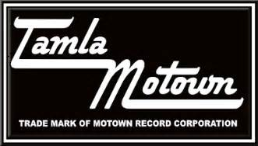
£5 ON THE DOOR

