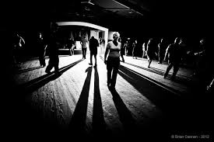
Soulville! @ Roose Cons
Leece Lane, Barrow LA13 0EB
Saturday 20th May

A night of Northern Soul

7.30pm till late
DJs Gary White, Paul McKeever, Chris Hughes,Roger Moffatt
Door tax £5 to a charity tbc

